Use Case Diagram and Descriptions- Dublin Walking Tour App

Use Case Diagram

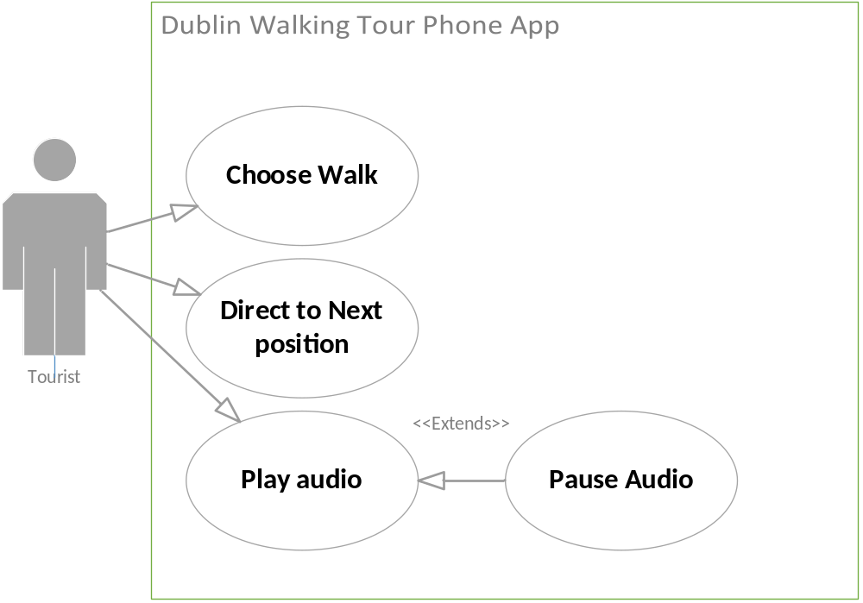

Use Case Descriptions

Dublin Walking App
Use Case: | Choose Walk
Actor (s): | Tourist
Goal: | The tourist wants to choose what walk to do.
Overview:
Type
Pre-Conditions | No preconditions
Post-Conditions | The walk is selected.
Special Requirements
Successful Scenario: | Step 1. The tourist opens the walk application by tapping on the live tile on the windows phone.
 | Step 2. The main screen shows a list of possible walks. Each walk will have a button to show a description of the walk and a button to start the walk.
 | Step 3. The user presses the button to start the walk.
Alternative Scenario (s) | Alternative step 3.The tourist opens the walk description and reads the description of the walk. The description also shows the location of the start of the walk. The tourist can either go back to the main menu and step 2 or choose to start the walk and go to step 3.

Dublin Walking App
Use Case: | Direct to Next Position
Actor (s): | Tourist
Goal: | To get to the next walk position
Pre-Conditions | The walk is selected
Post-Conditions | The tourist arrives at the position
Successful Scenario: | Step 1. Once the walk is selected or the previous audio has been played a map screen comes up on the phone
 | Step 2. The map shows the phone location and the next walk position
 | Step 3. The app directs the tourist to the next walk position from the current phone location.
 | Step 4. Once the tourist arrives the location go to the play audio use case.

Dublin Walking App
Use Case: | Play Audio
Actor (s): | Tourist
Goal: | To play the audio information for a location
Overview: | The audio information for a certain walk position is played
Type
Pre-Conditions | The walk is selected and the tourist has arrived at the walk position
Post-Conditions | The audio information listened to.
Special Requirements
Successful Scenario: | Step 1. When the tourist arrives at the walk position the audio information for that location is played automatically.
 | Step 2. After the audio is complete the app finds the next walk position and the direct to next walk position use case is used
Alternative Scenario (s) | Alternative step 1. The audio can be paused at any time. When paused and the tourist goes out of the app, the app is resumed at the paused page when the tourist comes back to the app.
 | Alternative step 1 When the tourist is directed to the first walk position of the selected walk. The tourist presses play to start the audio information for that location.
 | Alternative step 1 When the last audio information file is complete the app is directed back to the main menu and the tourist can choose another walk.

Class Diagram

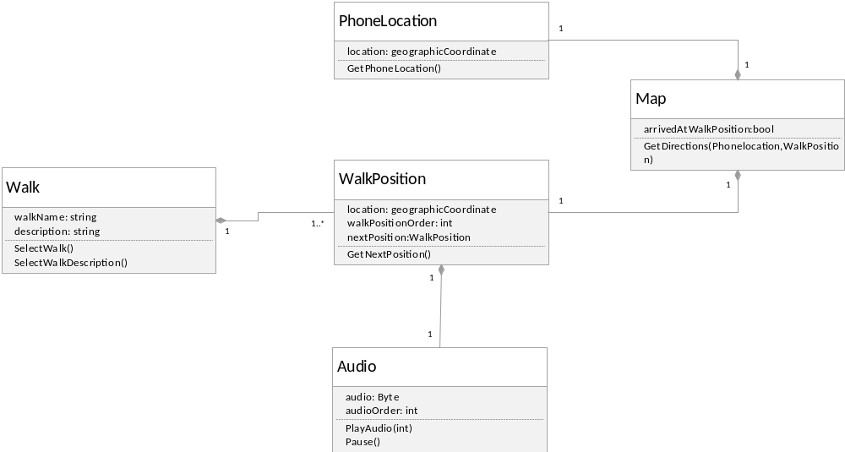

Sequence Diagram
